Assignment 4

Binary Search Trees

by WTBROC002

Roche Witbooi | CSC2001F | 17 April 16, 2023

Contents

Object Oriented Design: 2

Testing values: 3

Choice selection 3

Choice 1: 3

Choice 2: 4

Choice 3: 4

Choice 4: 5

Choice 5: 6

Choice 6: 6

Choice 7: 7

Choice 8: 8

Creativity: 9

Choice 9: 9

Choice 10: 9

Choice 11: 9

Git log 10

10

# 

# Object Oriented Design:

TokTik contains the main program that the user interacts with. The TokTikHelper class contains code helper methods to avoid retyping code in the TokTik program.

A Binary Tree is used as the main data structure to store accounts used in the TokTik program. It is an efficient structure for storing many accounts as it allows the user to access and delete accounts faster than a linked list or array. Furthermore, there is no bound to the number of accounts that can be stored. The Account class represents the TokTik users. Each account is unique; however, all accounts have a unique username description, posts, and followers. By creating an Account class account objects can be created with unique values for each user. Since a user can have multiple posts the Post class is created to store the unique attributes associated with each post. A post has a title, video name, and several likes and is stored in a user account using an Array List. Similarly, a user also may have followers, these are accounts stored as a binary search tree which is an attribute of the Account class.

The Binary Search Tree is implemented using the main BinaryTree class and its functionality is extended using a child class Binary SearchTree which implements the insert, find, and delete operations. The Binary Tree is made up of nodes that store the data object in each node, together with the left and right child nodes to support the Binary Tree Structure. The BTQueue class is used to implement the Queue data structure for level Order traversal. The Queue is made up of BTQueueNodes which store the Binary Tree Nodes during level order Traversal.The Binary Tree, BinarySearchTree, BinaryTreeNode, Queue, and BTQueueNode are implemented as generics to allow for the code to be repurposed in various scenarios by inserting different classes into the datatype variable.

The TokTik program uses the generic classes that help implement the BinarySearchTree to store Account objects. The Account class is inserted as “dataType” parameter in the generic classes this allow the Binary Tree to store accounts.

# Testing values:

## Choice selection



The user is required to enter a numeric value between 1 and 11 which corresponds to an action.

When the value entered falls outside boundaries 1 and 11, the user is prompted to select an option in the valid range.

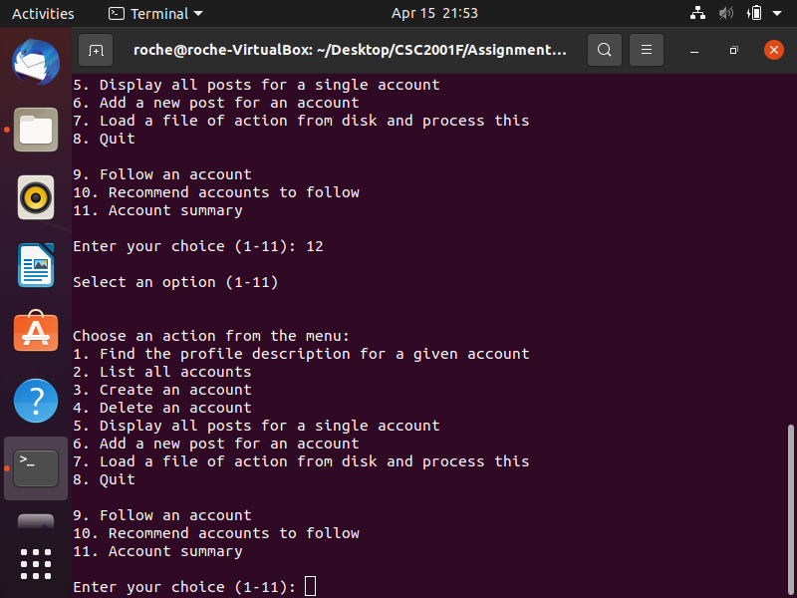

The values **12** and **0** have been provided.

The program provides the message: **“Select an option (1-11)”**

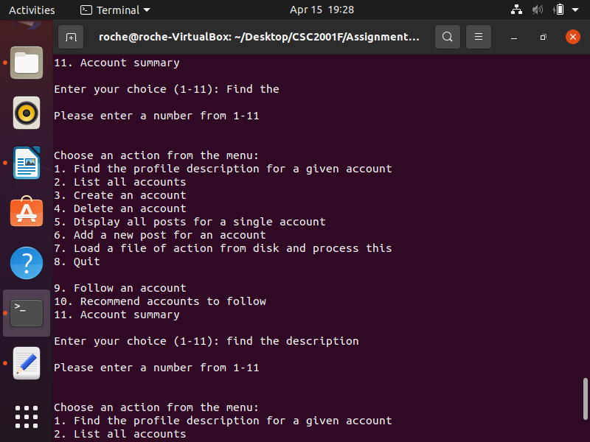In the case where the user enters text instead of an integer, the program prompts the user to enter a number.

The text “**find the description**” is entered by the user. The program responds with the message “**Please enter a number from 1-11**”.

## Choice 1:

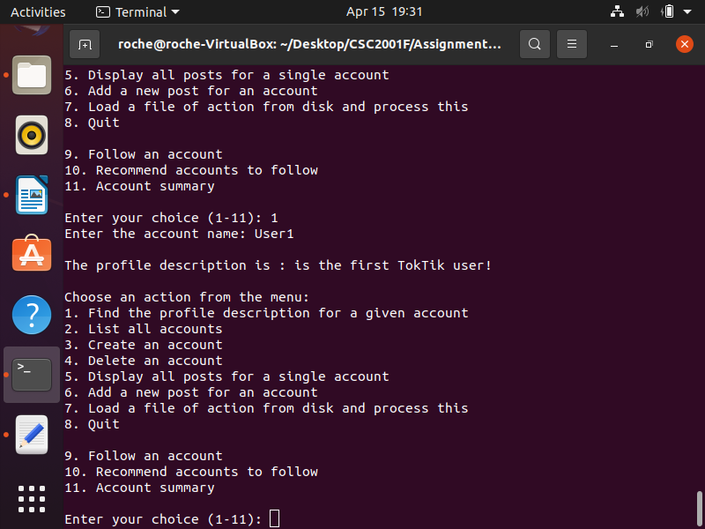The program is required to find the description of an account that corresponds to the account username entered.

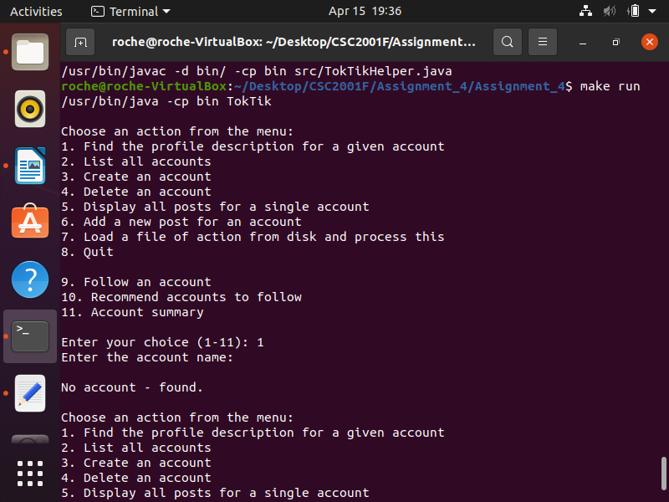The account with the username “**User1**” is provided by the user. The program finds the account details and displays the account description **“ is the first TokTik user!**”

Where the user enters a space instead of the account name the program responds with the message “**No account - found**.”

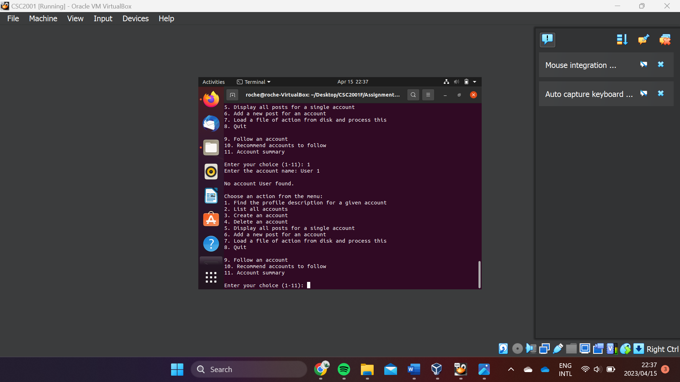If an account that does not exist is entered, the program informs the user the account has not been found.

Where the user has entered a space in the account name, the program takes the first word as the account name. In this case, “User 1” is provided. Since there are no accounts with this username, the program displays the “No account <entry> found” message

## Choice 2:

The program is required to list all the users of TokTik. The program does this by first stating the account username followed by the username.

In this caseTokTik only has two users “**User1**” and “**User2**”.

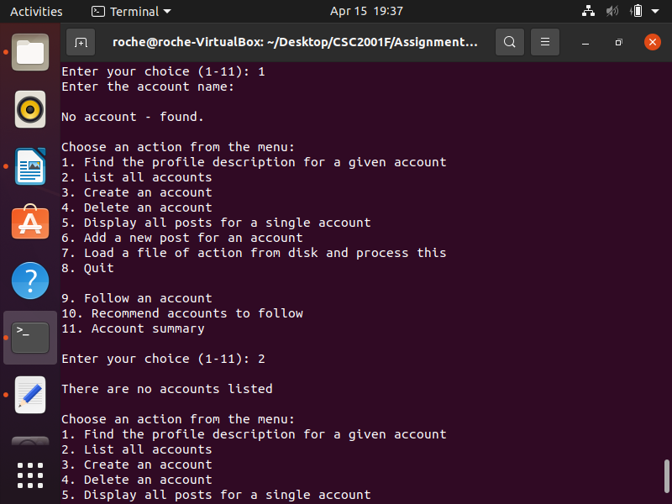Once TokTik has more accounts this selection will list all the accounts. To the left are the first four accounts listed after processing the **dataset.txt** file, the remaining accounts are also listed below these four lines.

If TokTik has no account users the program displays the message” **There are no accounts listed**”

## Choice 3:

Selection 3 allows the user to create new accounts by entering a Username and description. The username should only be one word. But the description can be longer.

The user has entered the username “**NewUser**” and the description “**new TokTik user**”. The program displays the message the <new account username> in this case “NewUser” account has been **successfully created**. This informs the user that the information they have entered is valid and a new account with their provided information is now stored in the TokTik system.

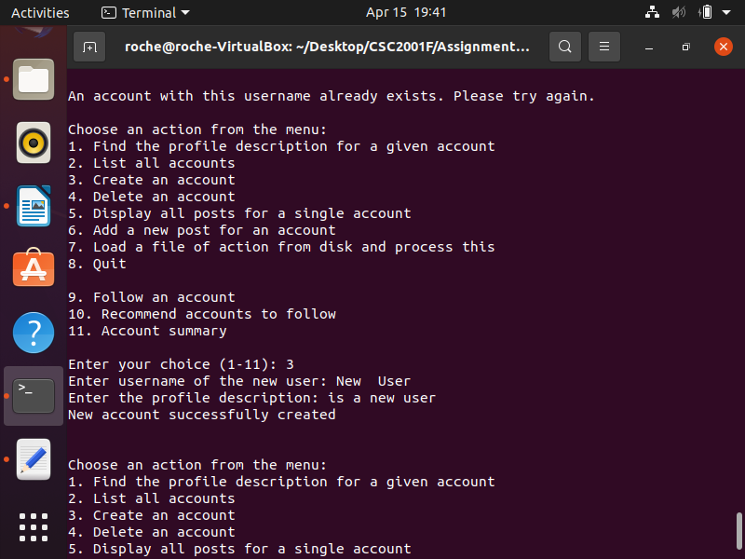Where the user has entered two words for the account the program will attempt to use the first word as the account username. Since the user has entered “New User” as the account username the program has created a new account using the first word “New” as the username.

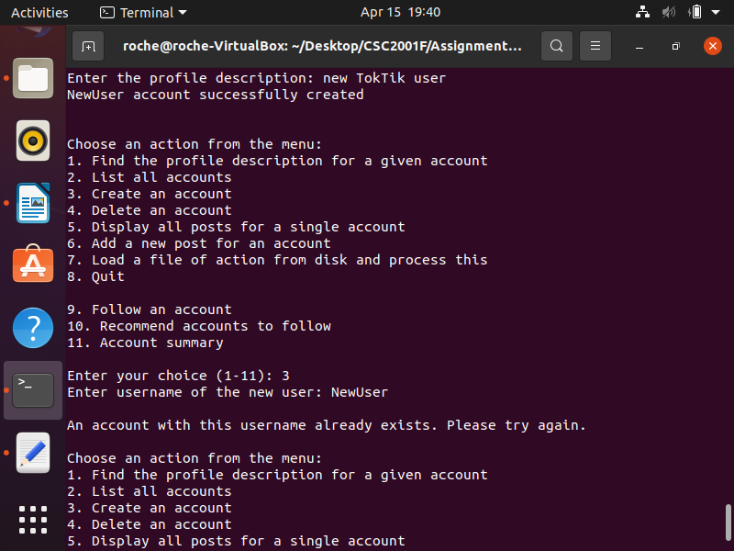The user has provided “**NewUser**” as the account username, but since this username already exists, the account cannot be created since all account usernames should be unique. The program, therefore, tells the user “An account with this username already exists. Please try again”. The user will then be taken back to the main selection options.

## Choice 4:

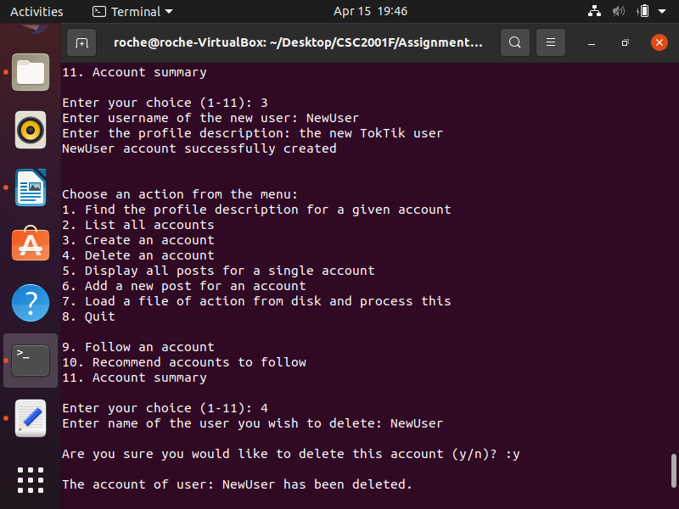Selection 4 allows the user to enter the username of an account they wish to delete. The program then requests that the user confirm the account deletion and based on the confirmation deletes the account if it is present in the TokTik system or not.

The user has entered the username “**NewUser**” and the user wishes to delete this account. The user confirms the deletion by responding with “**y**” to the prompt “**Are you sure you would like to delete this account (y/n)?**”. The program then displays a deletion message “**The account of the user: <entered username> has been deleted** ”.

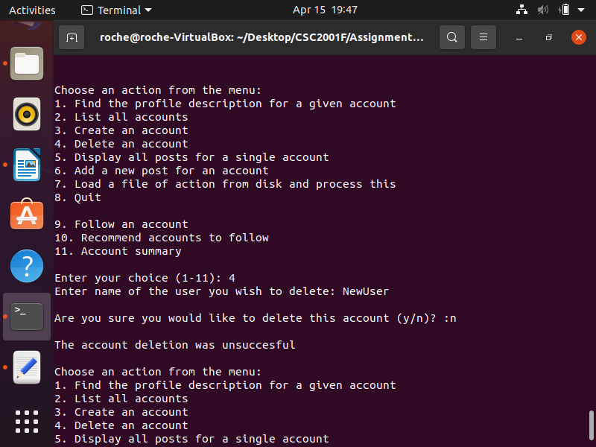The user has entered the username “**NewUser**” and the user wishes to delete this account. The user changes their decisions and does not confirm the deletion by responding with “**n**” to the prompt “**Are you sure you would like to delete this account (y/n)?**”. The program then displays a message indicating that the account has not been deleted by displaying “**The account deletion was unsuccessful**” Text
However, in the case where the account username entered does not belong to an existing account the program displays “**The account you wish to delete does not exist**”. Since the account entered “**User1**” is not an existing account the message was produced.

## Choice 5:

By selecting this choice the user enters an account and all the accounts posts are listed from latest to oldest.

The user has entered the account username “**NewUser**”. The program, therefore, lists all the user’s posts beginning with the most recent posts.

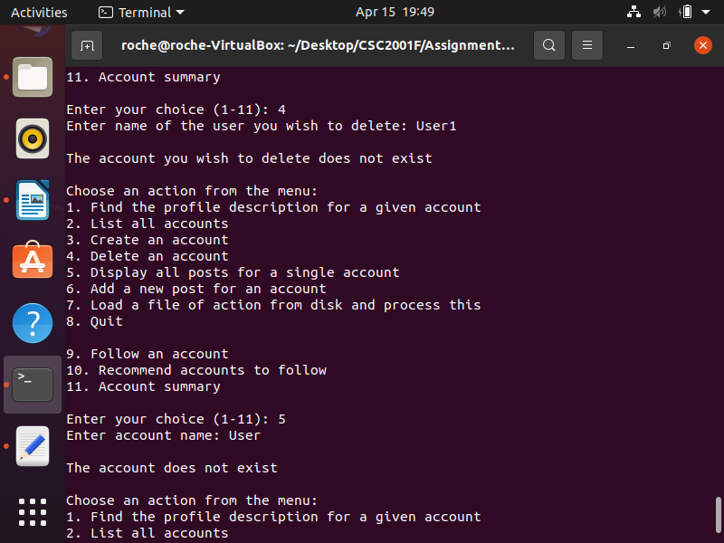In the case where the user entered does not have any posts the program displays the message **“<account name> does not have any posts**.” In this case “**NewUse**r” has not made any posts.

Where the account entered “**User**” is not an existing account the program displays the message “The account does not **exist**”

## Choice 6:

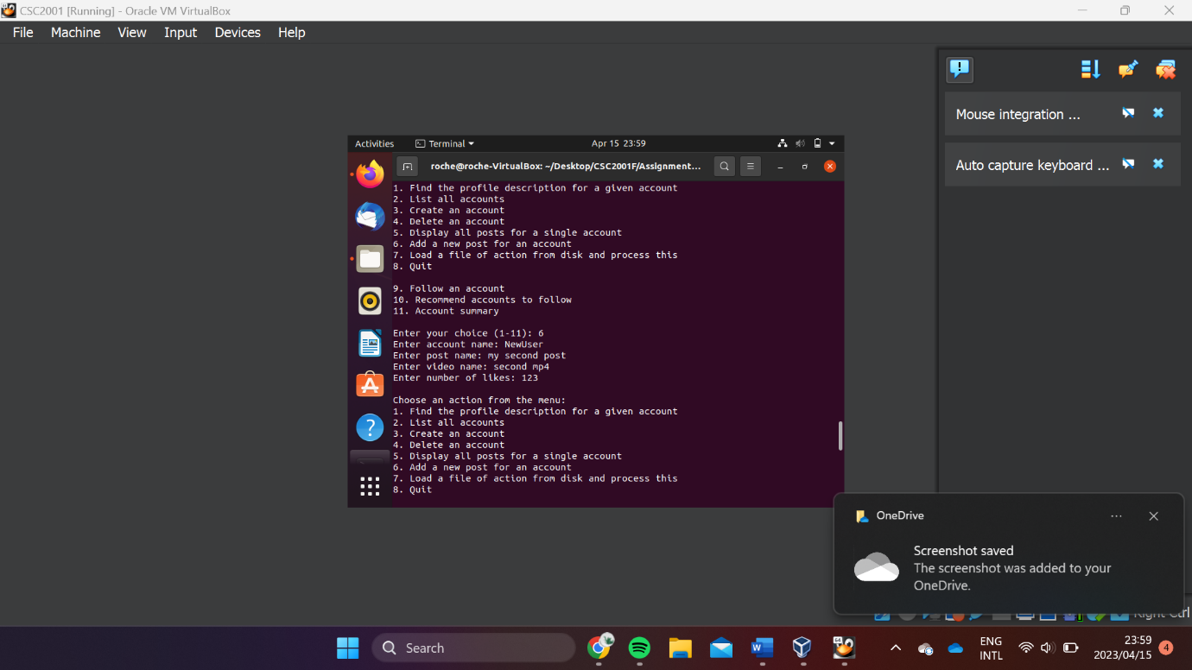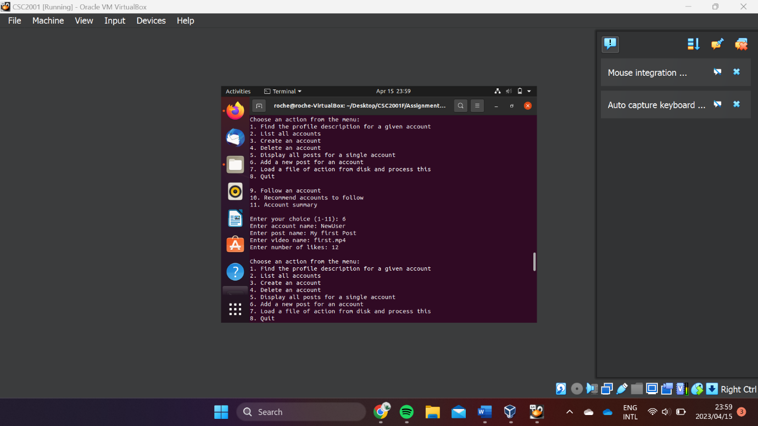Selection six adds a post to an account. The user is prompted to enter an account username, the post name, the video file name, and the number of likes. The post is created and added to the corresponding user account entered.

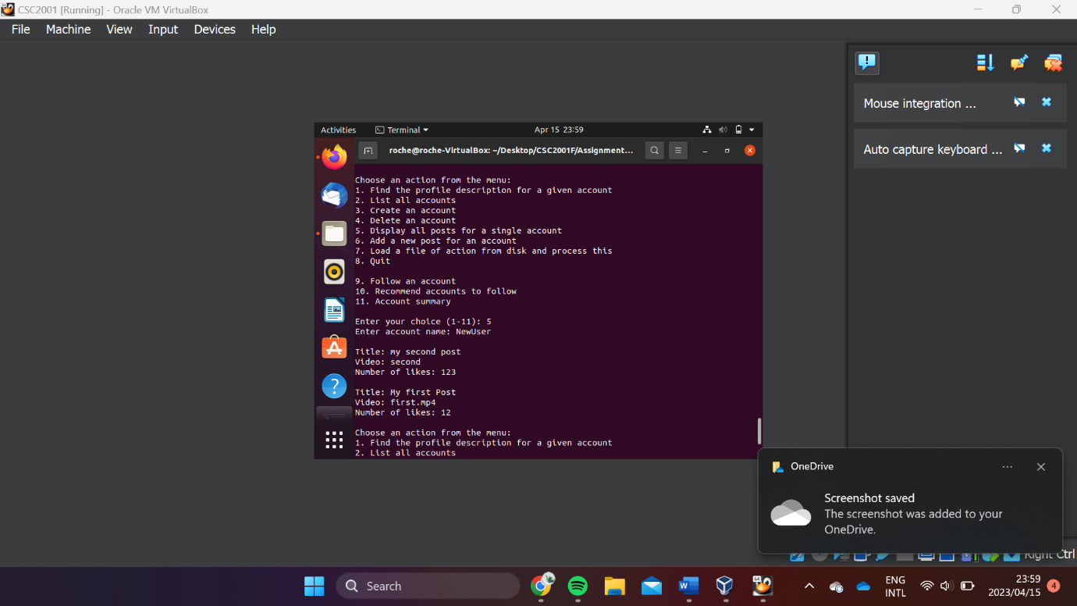The user has entered the username “**NewUser**” and wishes to create a post “**My first Post**” with the video file name “**first.mp4**” and the post has “**12**” likes. The post is then added to NewUser’s account.

Where the user has entered the video name “**second mp4**” the program uses the first word as the video name.

The account “NewUser” now has two posts the first with all the information as entered and the second with the adjusted video name, corresponding to the first word entered.

Where the user has not entered a value for the number of likes. For example, “**last**”. The program displays a message, “**The number of likes must be an integer greater than 0**”. The post is not added and the user is directed back to the main selection options.

Where the user enters an account user that does not exist like “Account1” the program displays the message “The account does not exist”.

## Choice 7:

The selection prompts the user for a file name and loads actions from the text entered in the file.

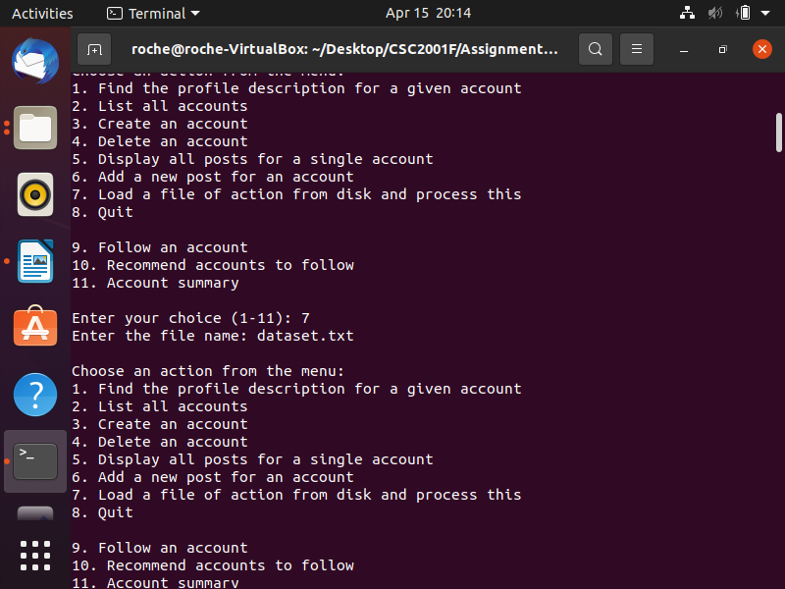The user enters the file name “**dataset.txt**”. The file is processed and based on the command in the file the program creates users and adds posts.

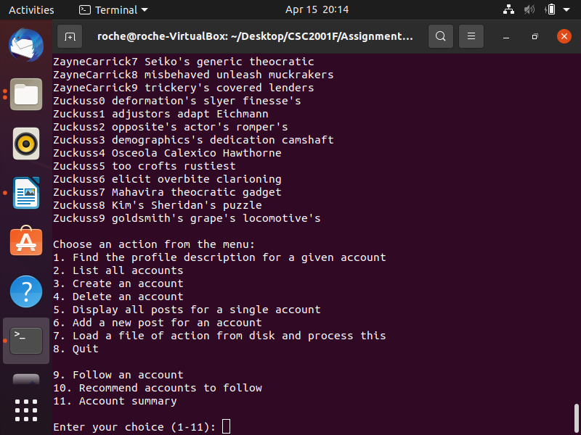The result of processing the file creates the accounts listed, some of the listed accounts have been omitted from the screenshots as the file is quite large. However, the first four and last six have been provided.

Where the file contains a command that does not begin with Add or Create like the provided “**Delete Greedo8 …”** line the program displays the line that does not conform to the standard and explains **“<the command line>: this action is invalid”** and that “**Commands must begin with Add/Create**.”

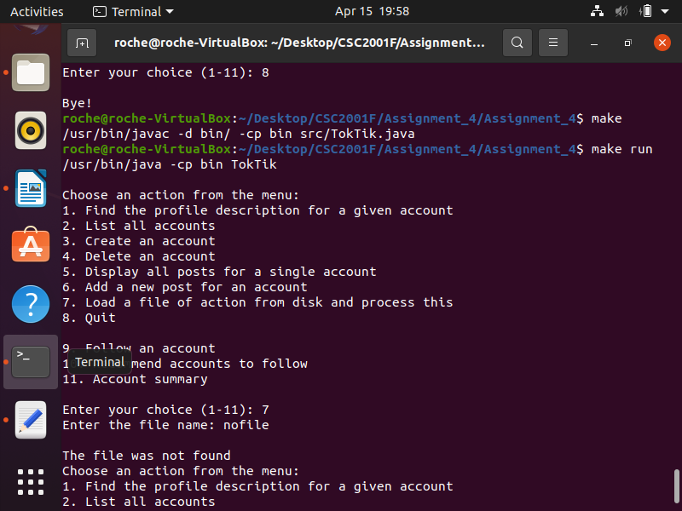Where the file name entered is not present in the program working directory the program produces the message “**The file was not found**”

## Choice 8:

The user selects 8 to terminate the program and the message “**Bye !**” is produced.

# Creativity:

The TokTik account management program additionally allows users to follow other accounts, recommends accounts for the user to follow, and displays a summary of the user’s information.

## Choice 9:

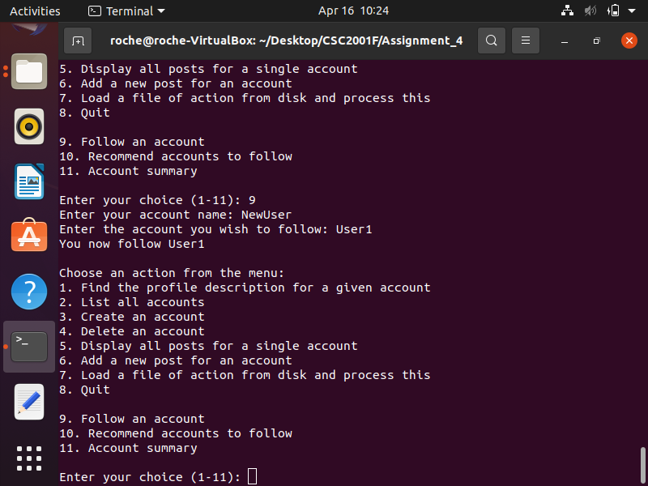 This selection enables the user to follow another user by entering their account name and the account they wish to follow. A Binary Tree is created for each account to store the account’s followers. This option checks that both the user’s account and the account they wish to follow exist before adding the user as a follower to the account entered.”

## Choice 10:

The user is recommended accounts based on an interest that they enter. The program then searches all the descriptions of all the accounts in the system for the word of interest. The program then lists all the accounts that are description contain the word of interest and asks the user if they would like to follow any of these accounts. The user then enters the username of the account they wish to follow. The user is then added as a follower of the account which requested to follow.

## Choice 11:

This selection allows the user to enter their username and obtain a summary of their account details.

The summary includes the account username and description. Furthermore, the user’s total number of posts and the details of the most popular post are displayed. The most popular post is the post with the highest number of likes. Lastly, the summary states the number of accounts following the user account and the number of accounts the user follows.

# Git log

## 